**Polynomials and Other Functions:**

**Cubic Functions:**

They have a third constant value, when displayed in a table of values

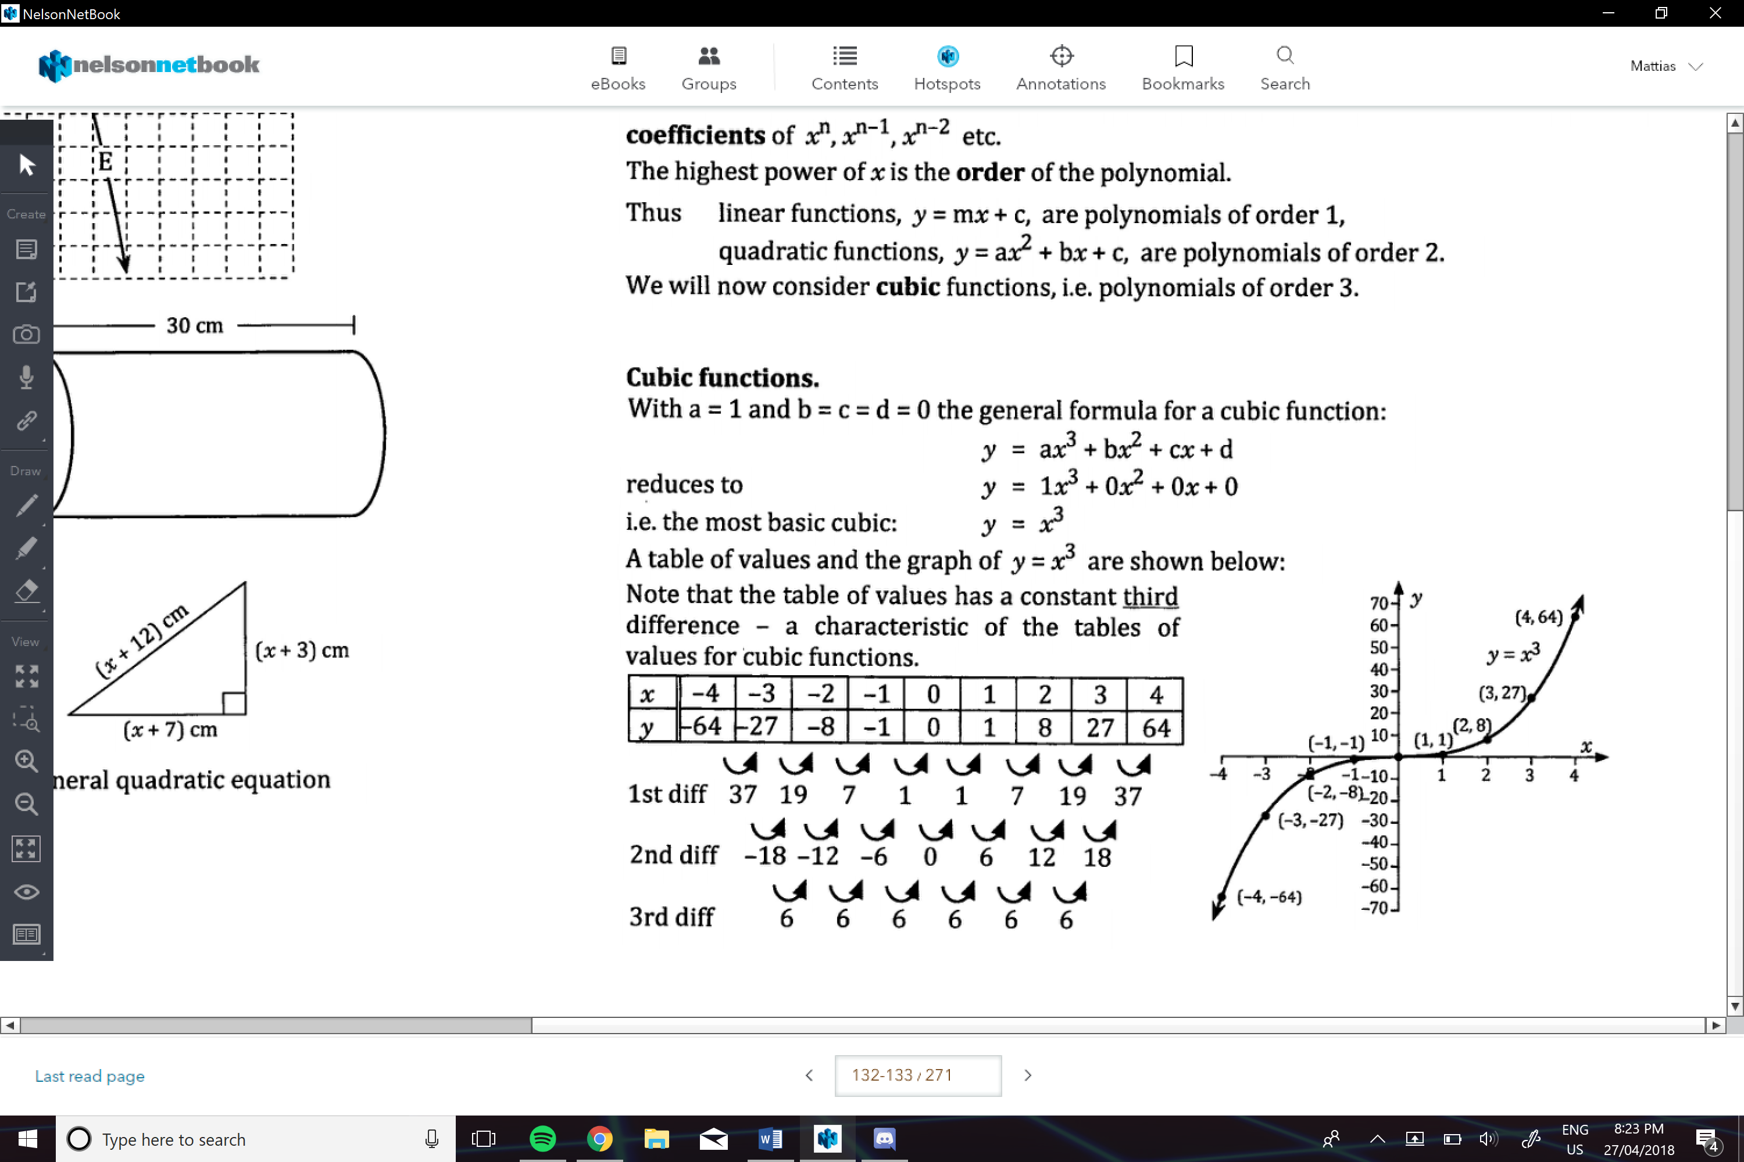

The expected Features of y=x3

* The line goes through the third and first quadrants respectively
* As x gets larger y will gets larger, as x gets more negative y will get more negative
* The start goes through 0,0

**Graphing:**

* Same as quadratic, in terms of finding t.p., L.O.S, roots…. Then graphing them

e.g.

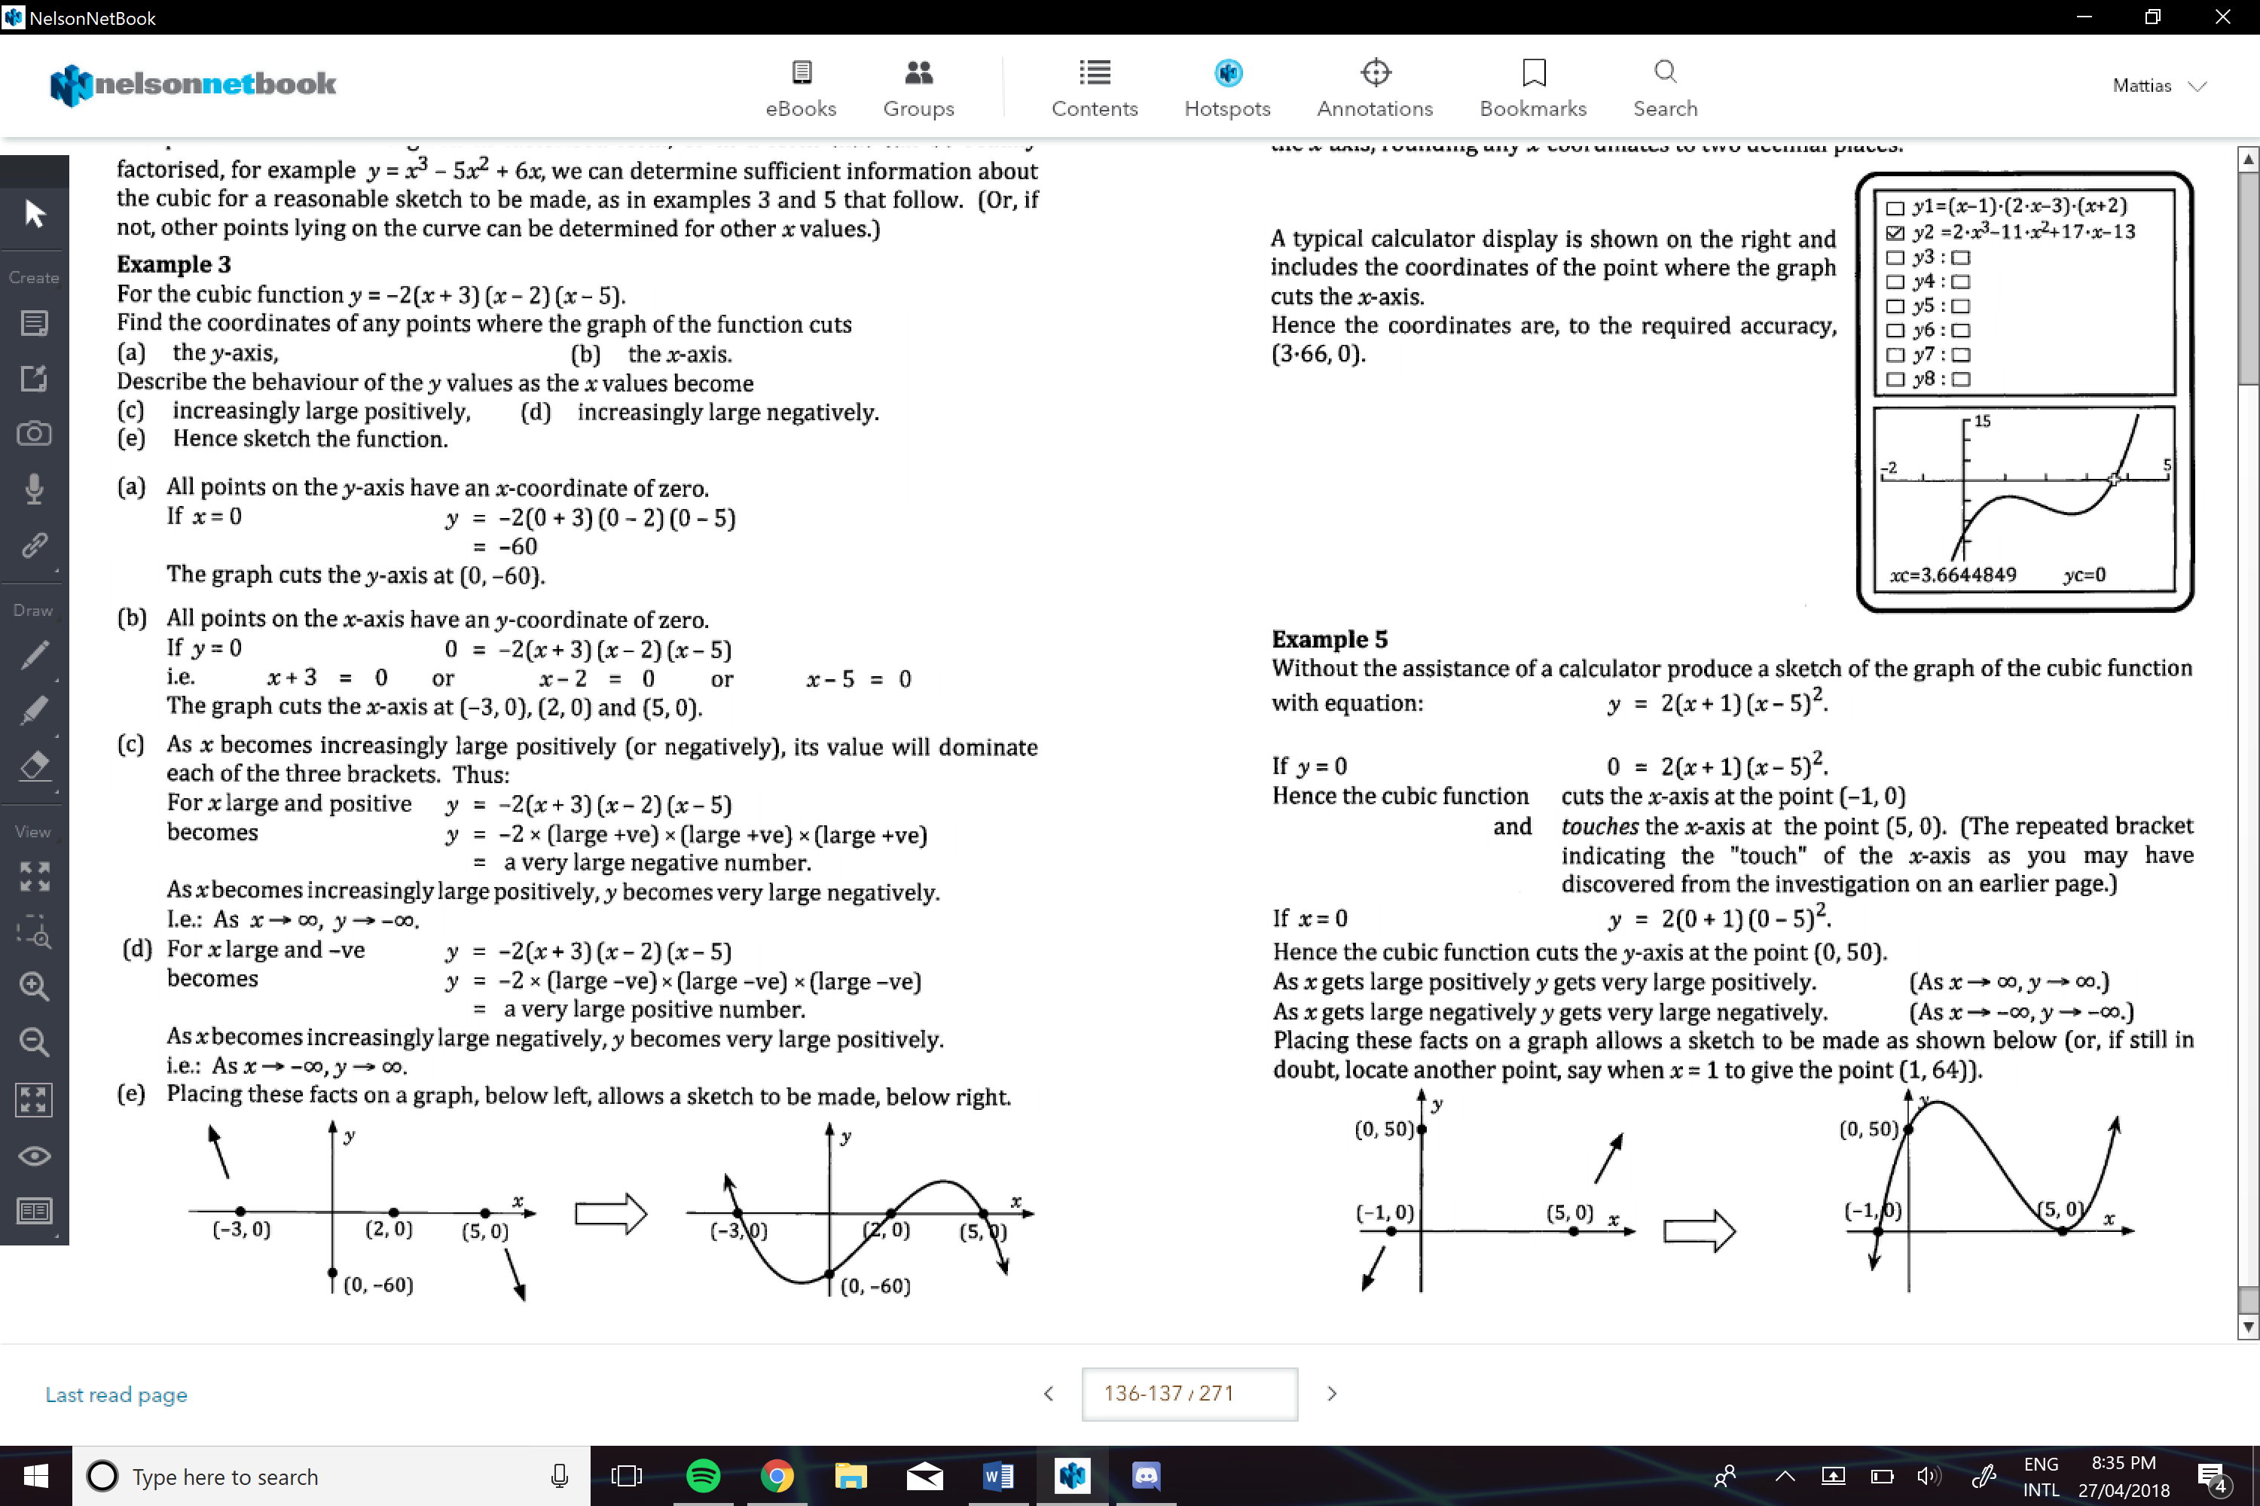

e.g.

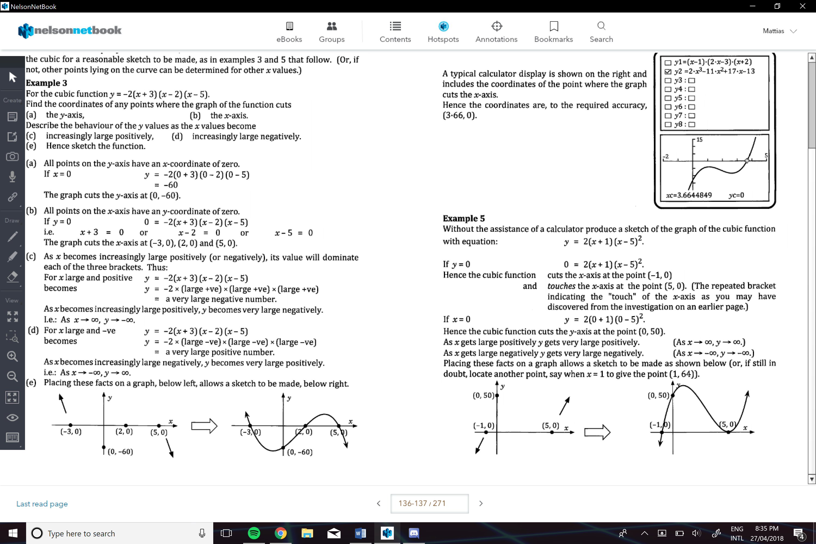

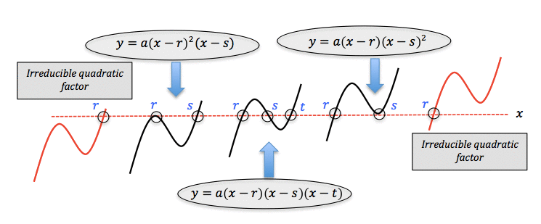

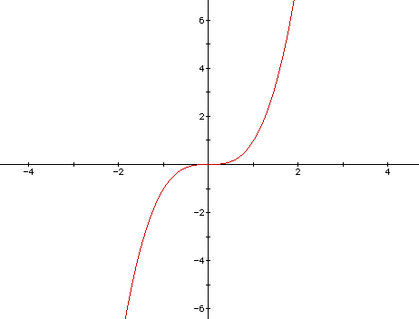

**Translations:**

y=a(x-b)3+c

* Dilate parallel to a scale factor of 1/a
* (reflected in y-axis if ‘a’ is negative)
* Translated b units right
* (if b is negative, translated left)
* Translated vertically upwards c units
* (if c is negative translated downwards)

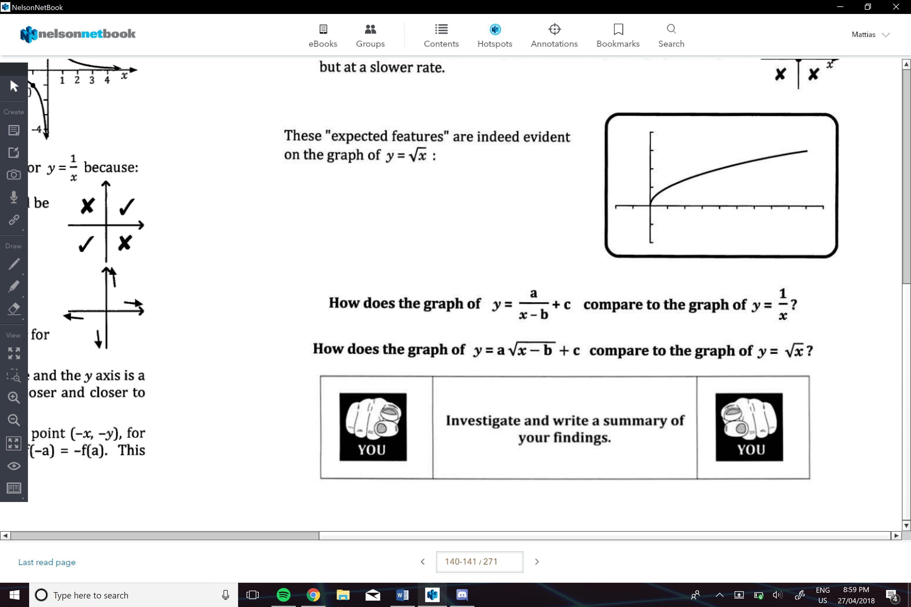**Square Root Function:**

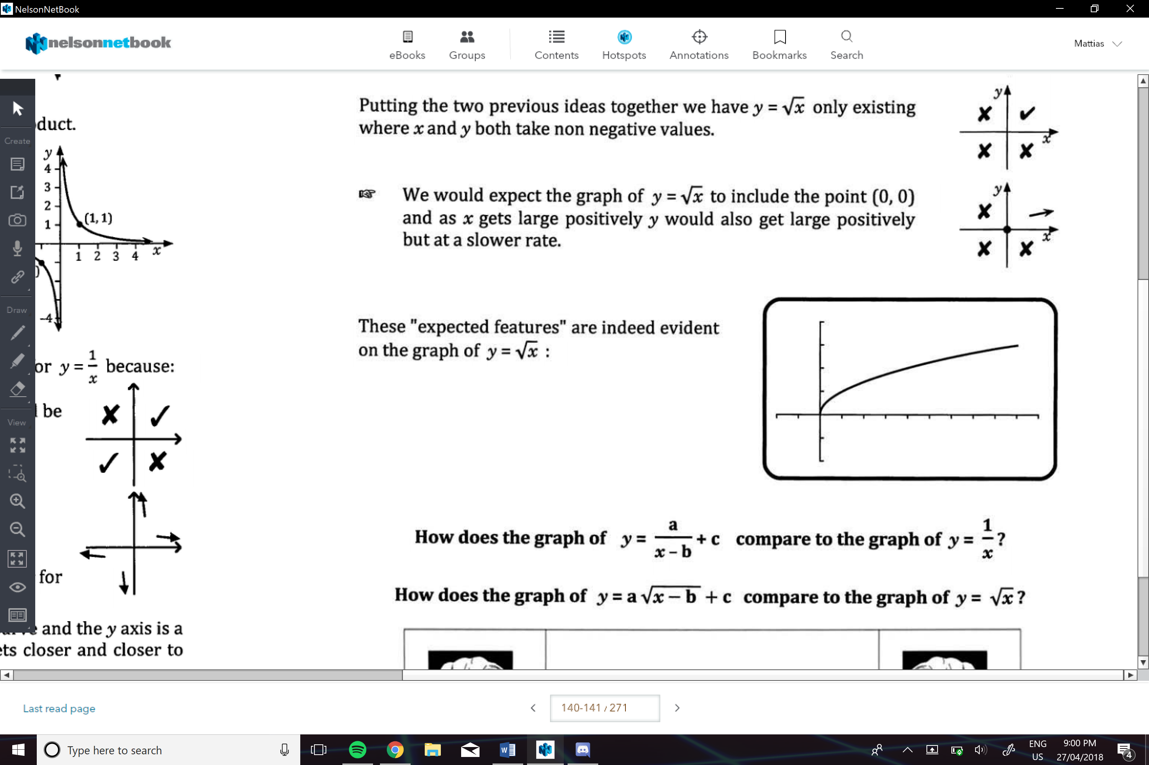

**Translations:**

* Dilate parallel to a scale factor of 1/a
* Translated b units right
* (if b is negative, translated left)
* Translated vertically upwards c units
* (if c is negative translated downwards)

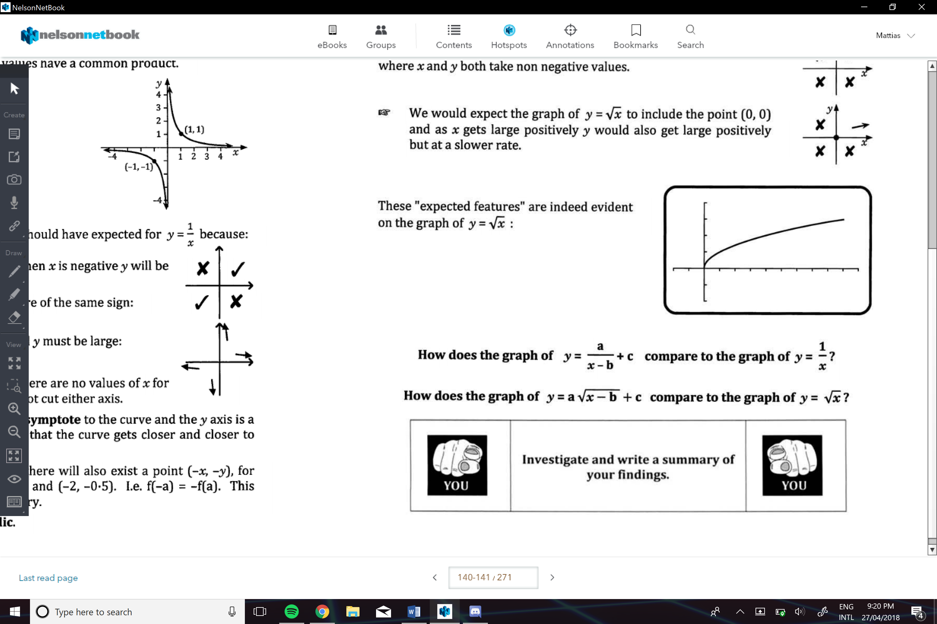**Reciprocal Functions:**

Expected Features:

* When x is positive, y is positive, when x is negative y is negative
* If x is large, y is small; when x is small, y is large
* The graph will not touch the y and x axis

Asymptote:

These are line that curve gets closer and closer without ever quite touching

**Translations:**

* Dilate parallel to a scale factor of 1/a
* Translated b units right
* (if b is negative, translated left)
* Translated vertically upwards c units
* (if c is negative translated downwards)

**

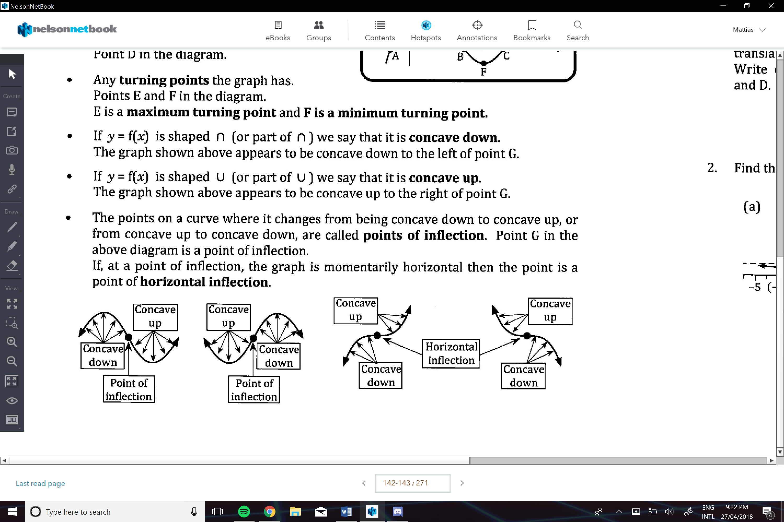

**Translation of a Function:**

y=a.f[b(x-c)]+d

1. *B*, Dilated parallel to a-axis, scale factor 1/b
   1. (reflected in y-axis if ‘b’ is negative)
2. C, Translated right c units
   1. (if c is negative, translated left)
3. A, Dilated parallel to y-axis, scale factor a
   1. (reflected in x-axis if a is negative)
4. D, Translates vertically upwards d units
   1. (if d is negative translated downwards)

*** if y=a.f(bx-c)+d

Then order is…

1. C
2. B
3. A
4. D

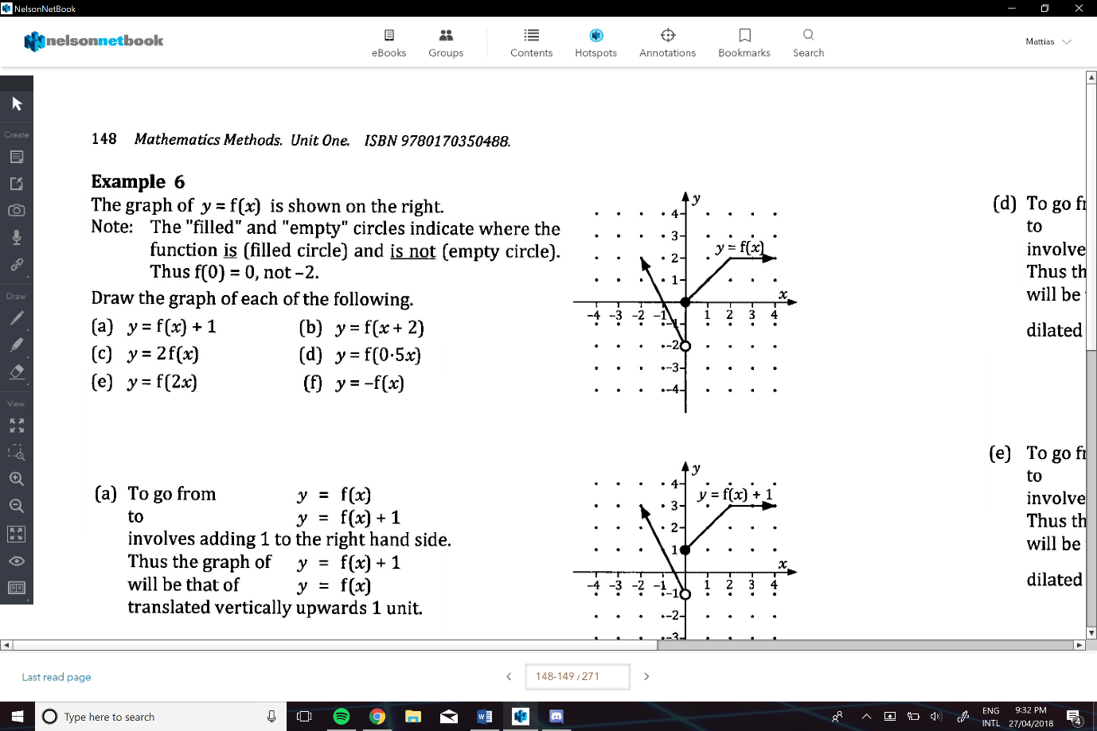e.g.

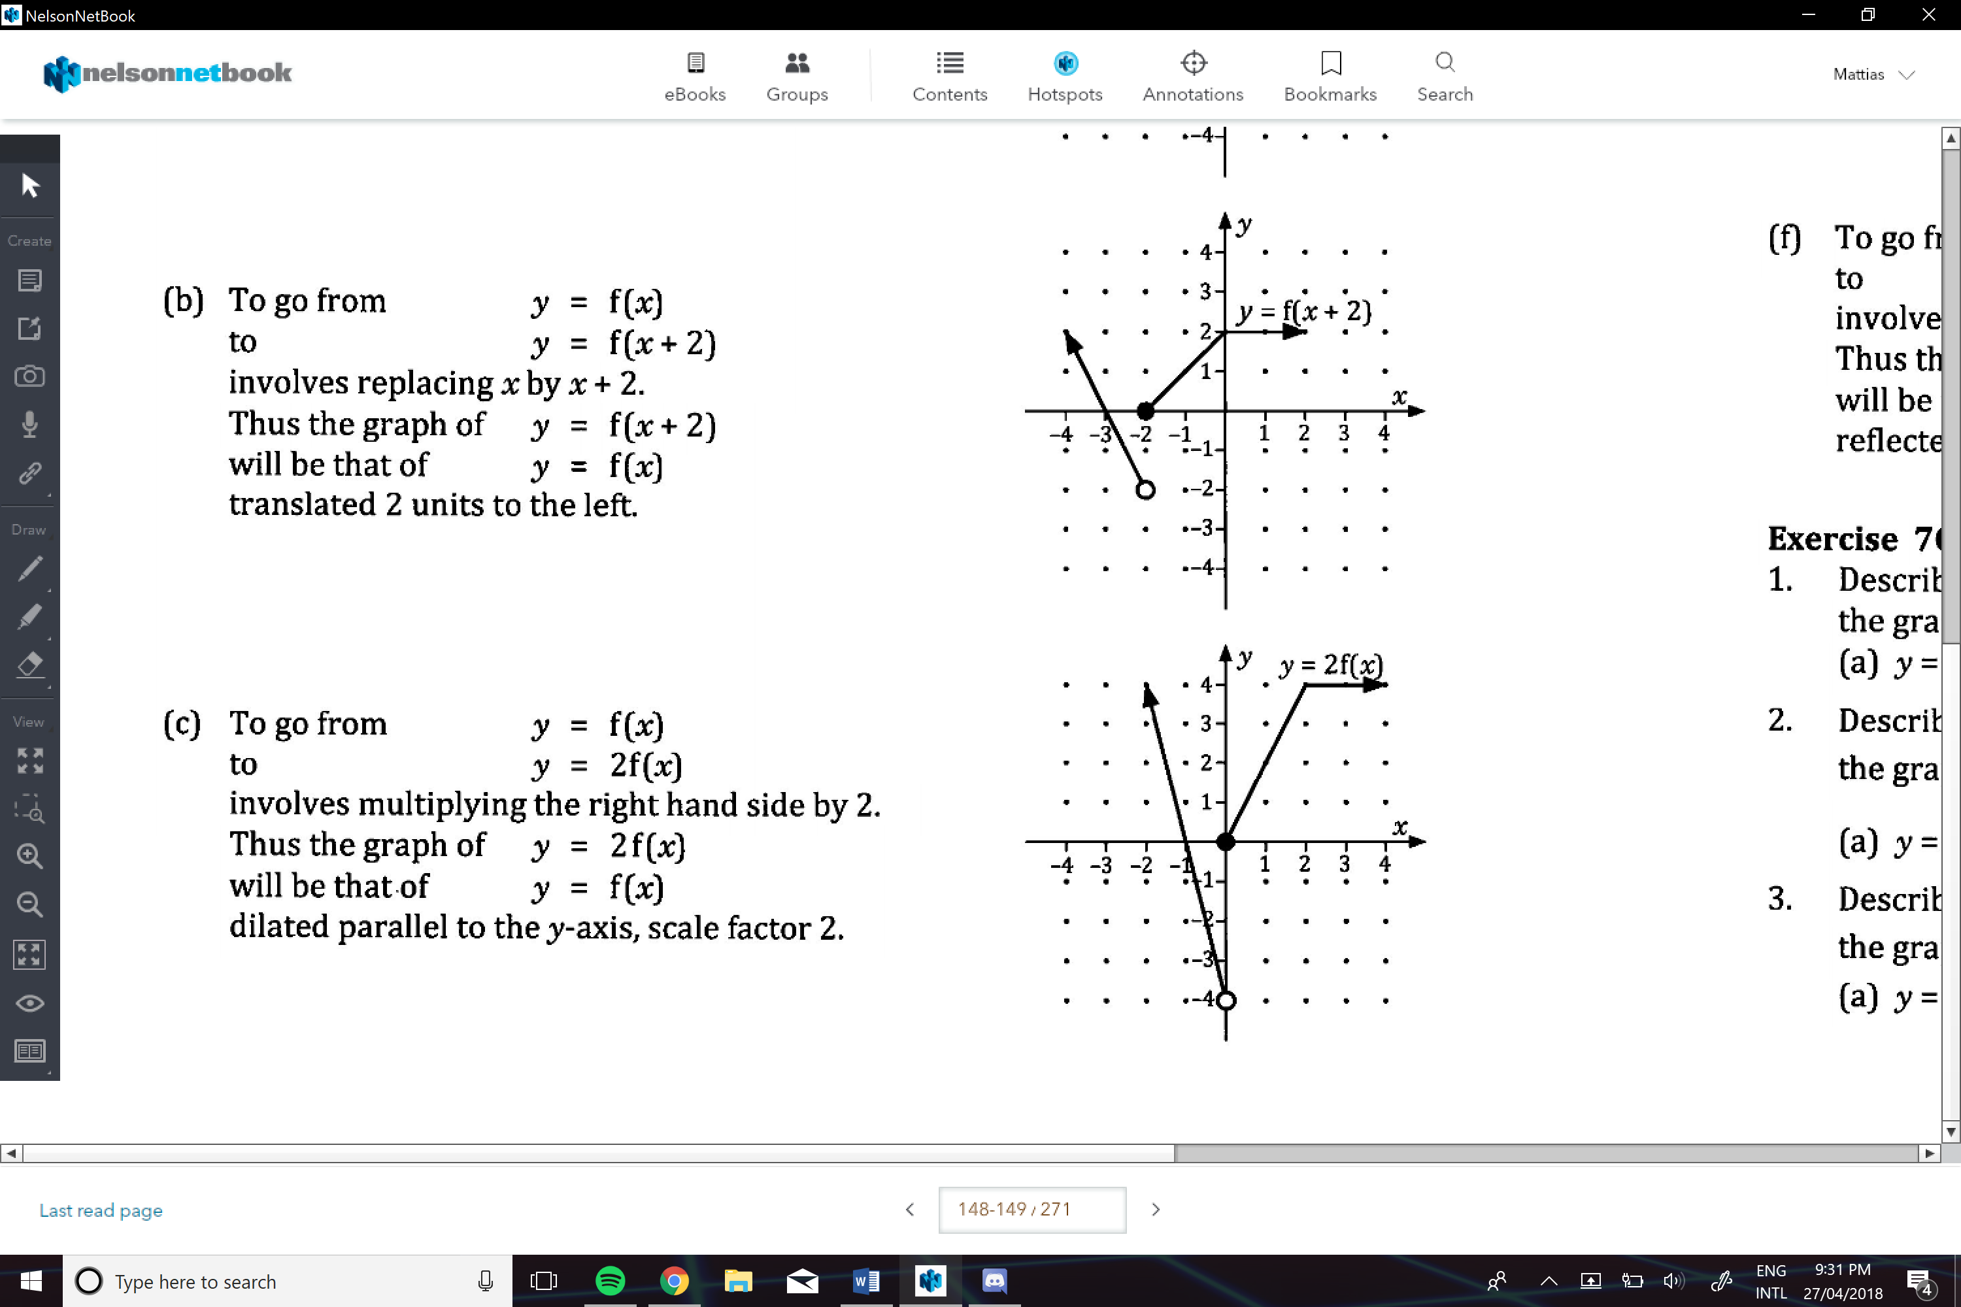

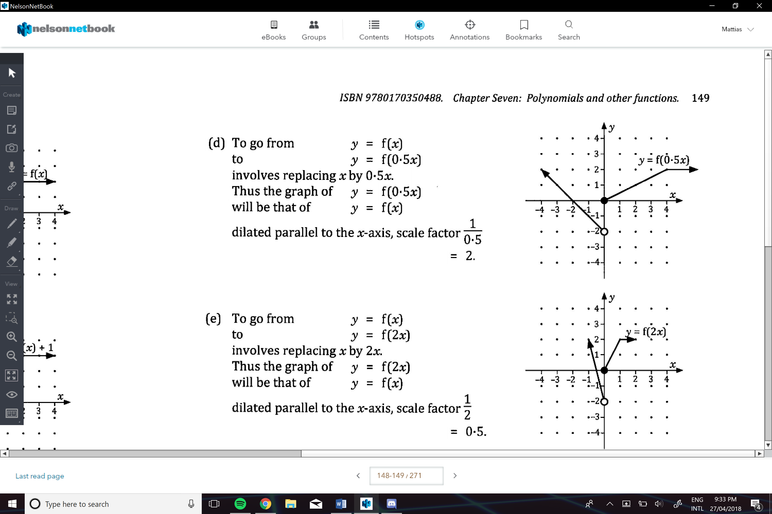

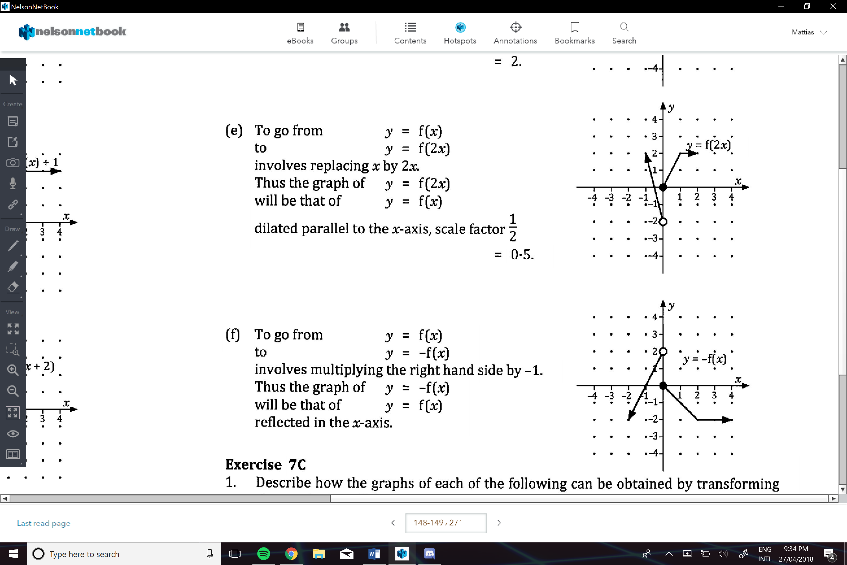

**Two Relationships that are not Functions:**

e.g. x=y2

-this is a one to many, therefore not a function…

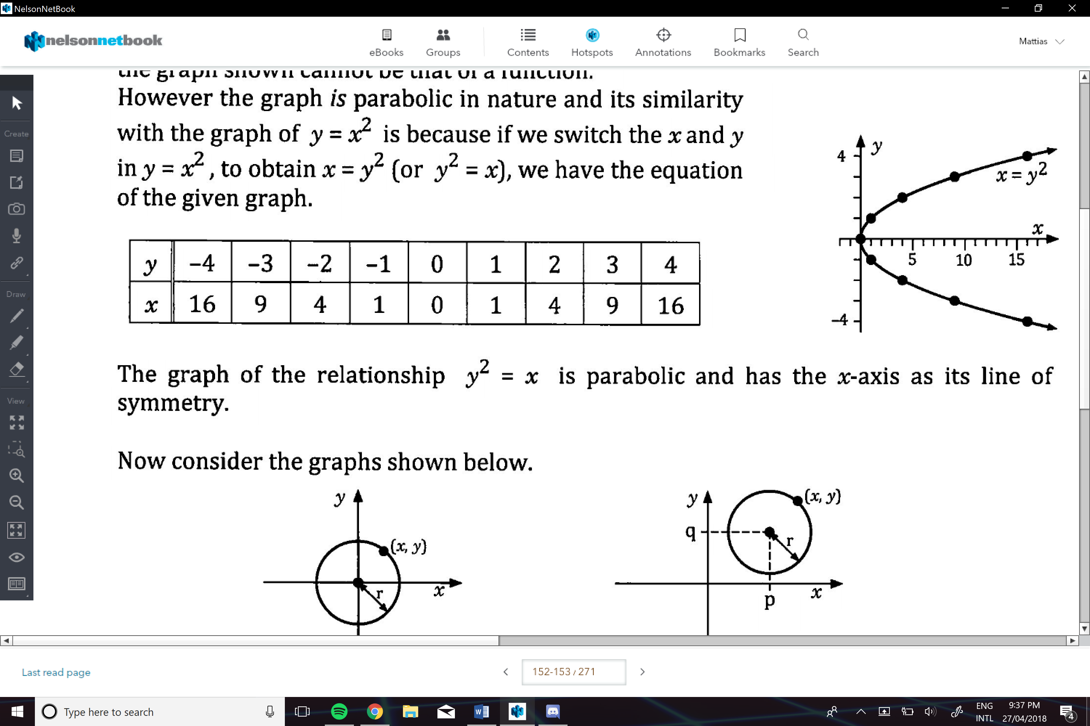

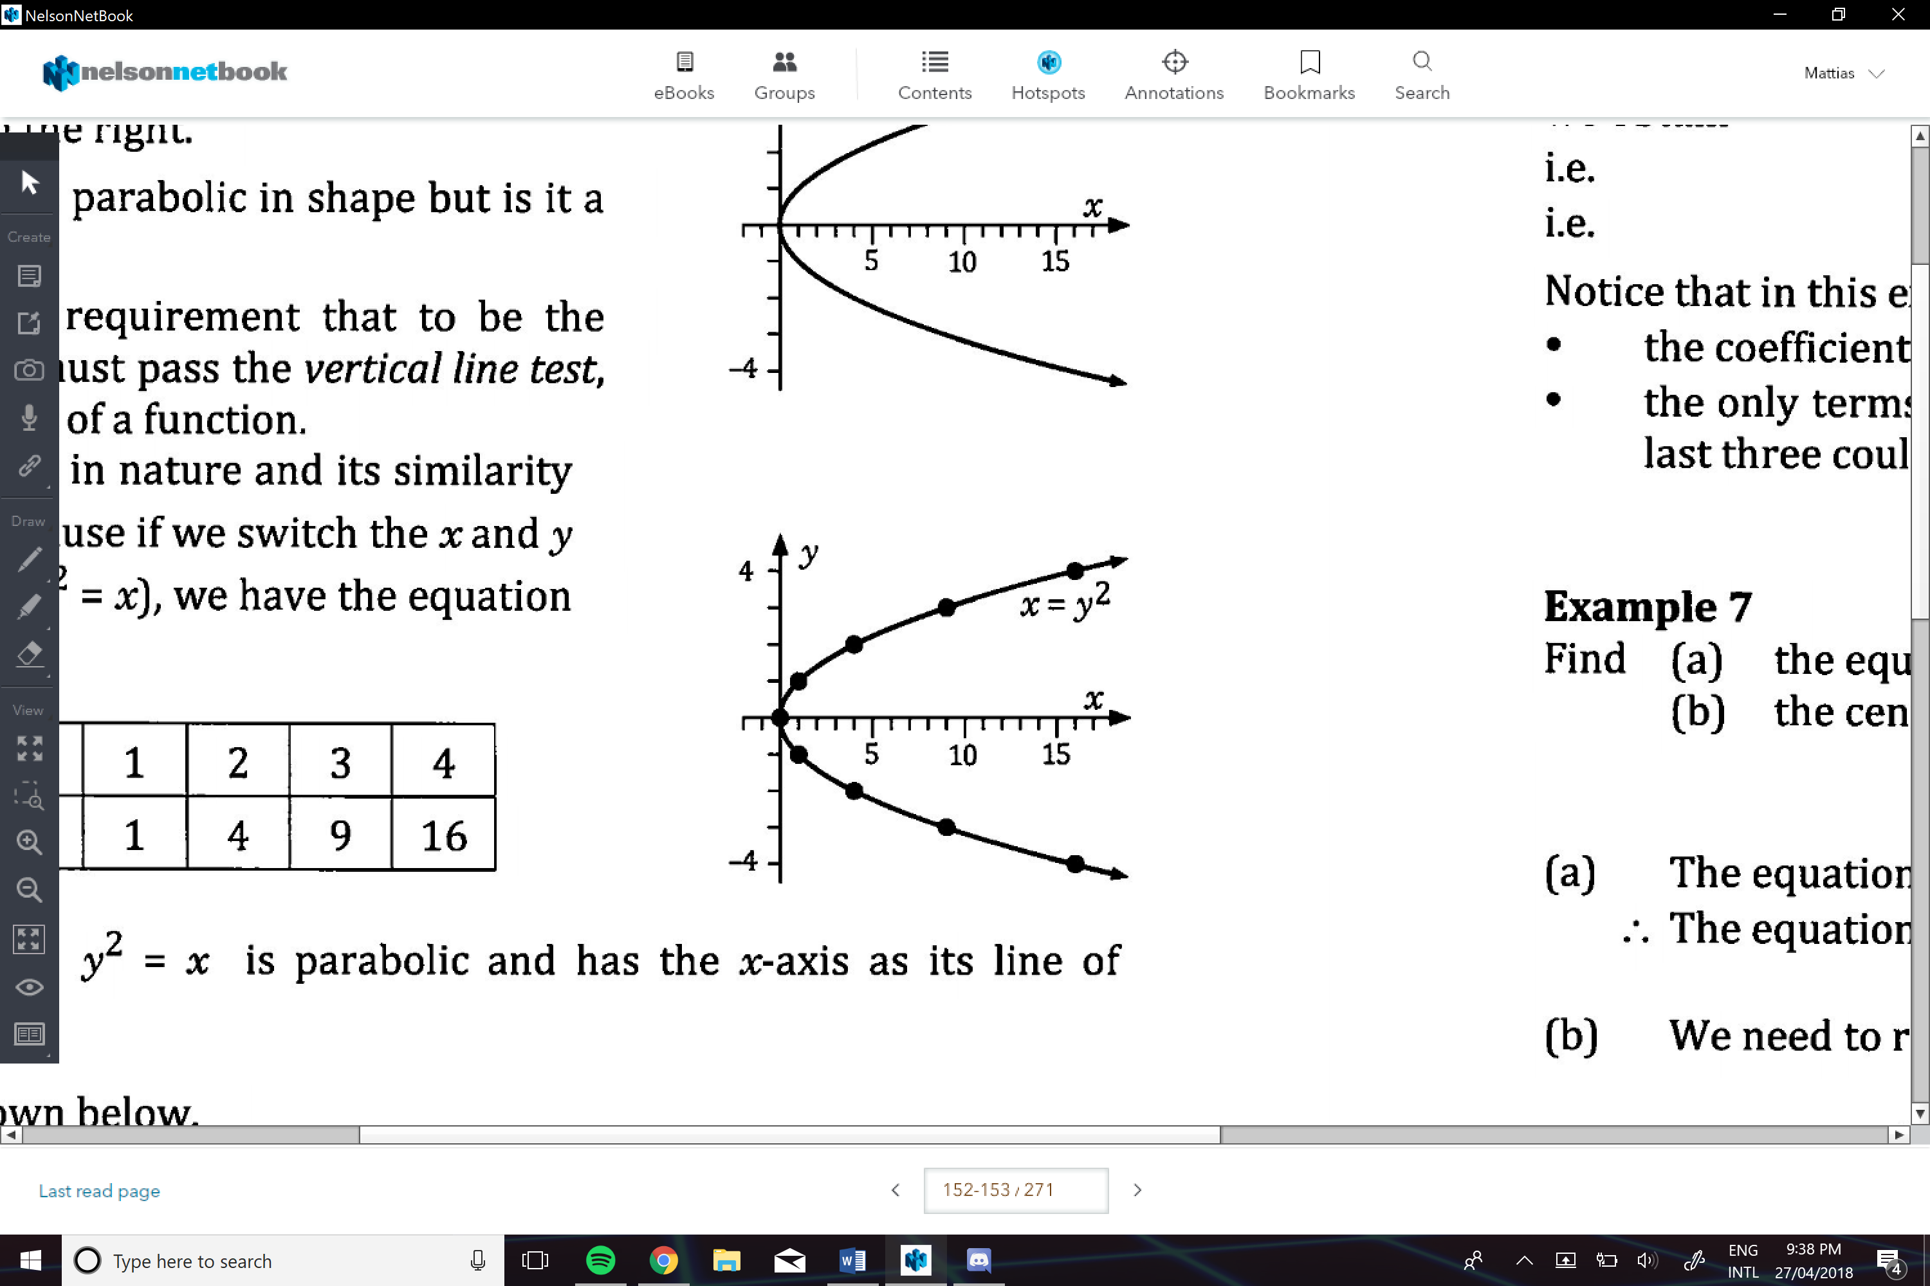

**Circle Formula:**

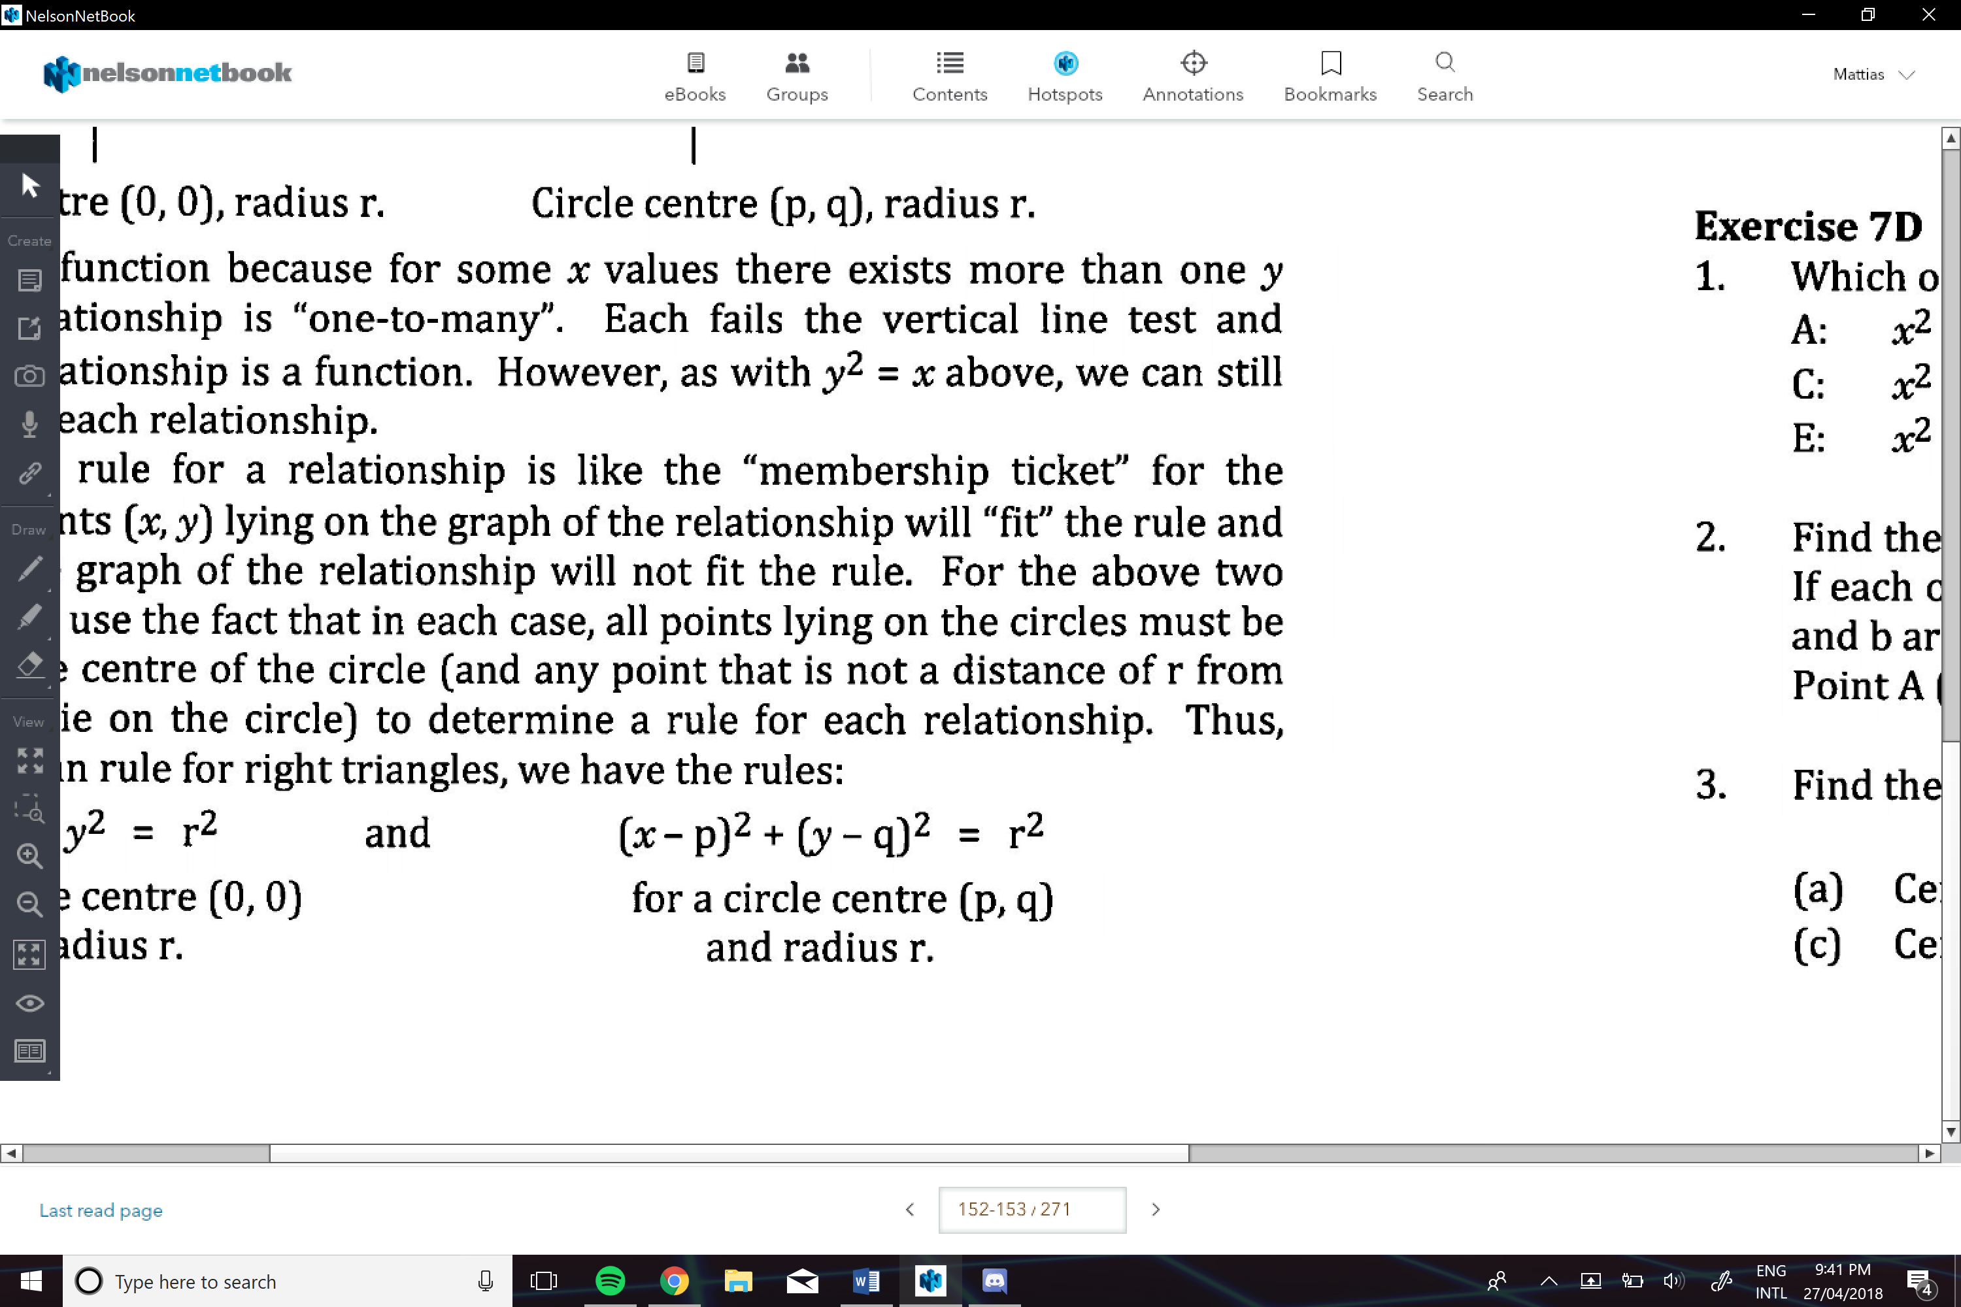

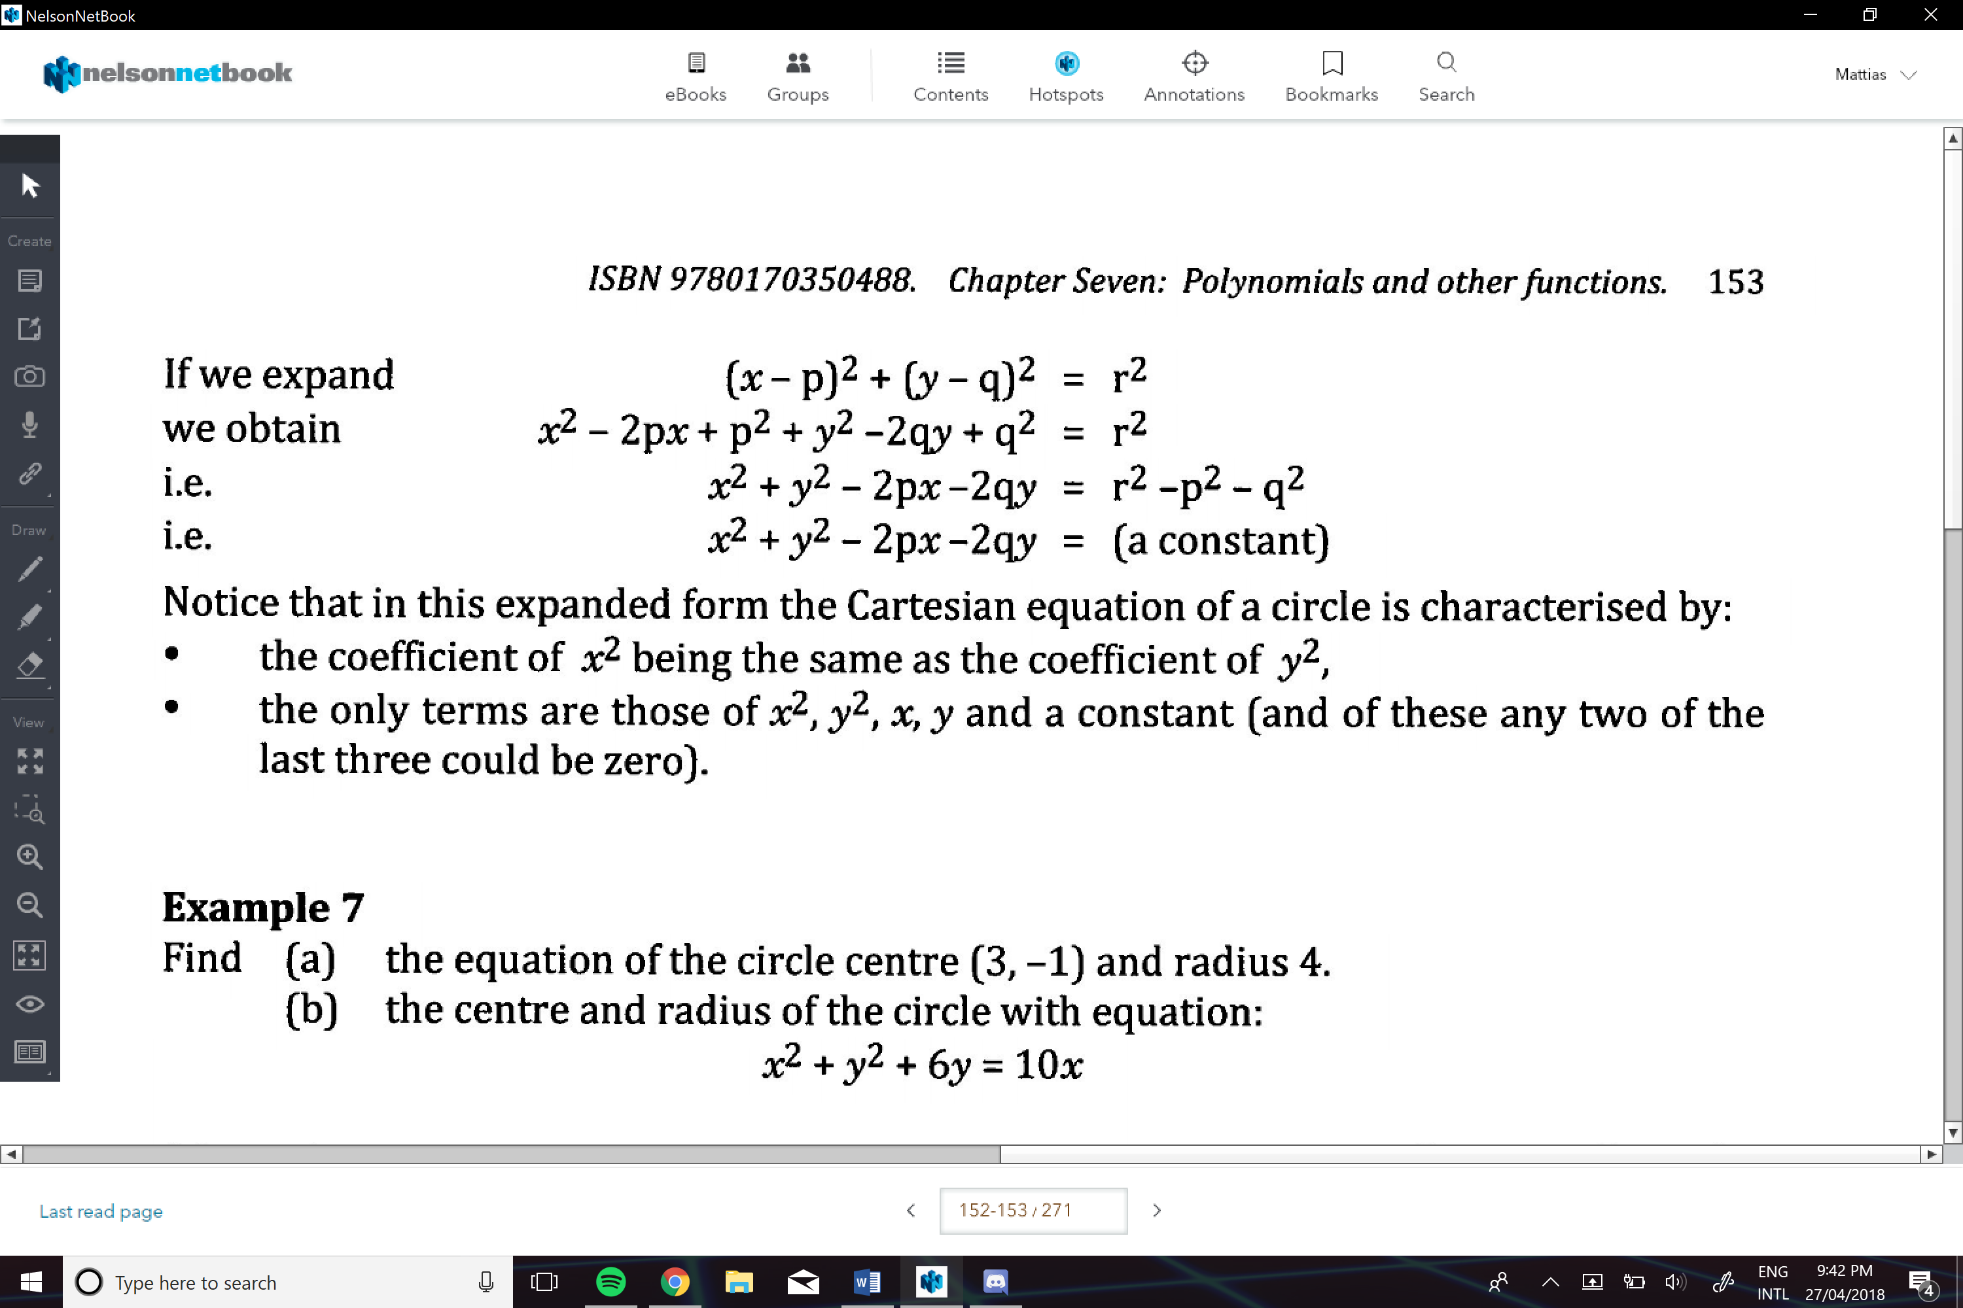

Therefore, we can use completing the square method to help us…

e.g.

